User Guide

The file provides clear instructions to help users navigate the app and its features, ensuring a smooth experience. It serves as a quick reference for common tasks.

Creating a user-friendly interface for an app is crucial and essential for enhancing User Experience. Therefore, we are planning to build the following interface for our app.

**Login Screen**

This page allows users to log in, continue as a guest, or create a new account to access the app.

* **Login Form**: Users can enter their **Email Address** and **Password** to log in.
* **Guest Access**: Tap **Continue as Guest** to explore the app without logging in.
* **Password Recovery**: Tap **Forgot your Password?** to reset your password.
* **Sign-Up Prompt**: Tap on **Register now** if you don’t have an account.

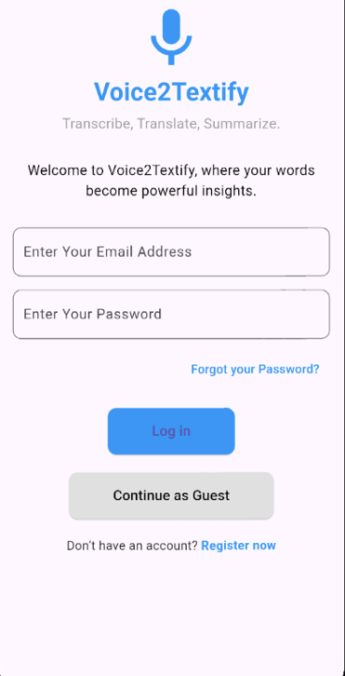

**Sign-Up Screen**

This screen allows new users to create an account and register for full access to the app features.

* **Input Fields**:  
  Users must fill out the following fields to create an account:
  + **Full Name**: Enter your full name for account identification.
  + **Email Address**: Provide a valid email address to be used for login and communication.
  + **Password**: Create a secure password for your account.
  + **Confirm Password**: Re-enter the password to confirm it matches.
* **Sign-Up Button**:  
  Tap the *Sign Up* button to submit your details and complete the registration process.
* **Navigation**:
  + Use the back arrow at the top left to return to the previous screen.
  + Ensure all fields are filled correctly before tapping *Sign Up*. Errors or mismatches will prompt a notification to correct them.

**Home Screen**

This is the main page where users can access key app features.

* **Start Transcription**:  
  Tap the microphone icon to begin voice-to-text transcription.
* **Start Translation**:  
  Tap the translation icon to start translating spoken language into another language.
* **Recent Transcriptions**:  
  Tap the clock icon to view previous transcription sessions.
* **Menu (Burger Icon)**:  
  Tap the menu icon to access additional options, including the **Log Out** button to securely log out.

**Notes:**

* **Guest Users**:  
  Some features, such as saving transcriptions, are restricted for guest users. These users can explore the app but will have limited functionality.
* **User-Specific Features**:  
  Data displayed, such as recent transcription sessions, is personalized and unique to the logged-in user. Guest users will not have access to saved sessions or personalized data.

**Transcription Screen**

This page allows users to transcribe speech into text in real time. The features available on this page include:

* **Mic Button**:  
  Tap to start or pause the transcription process. Speech will be transcribed and displayed on the screen in real time.
* **Clear Button**:  
  Tap to clear the current transcription from the screen.
* **Save Button**:  
  Tap to save the current transcription to your account. This feature is unavailable for guest users.
* **Real-Time Transcription Display**:  
  The transcription appears on the screen as you speak, updating in real time.

**Translate Screen**

This page allows users to translate transcribed English text into a selected language.

* **Language Selection Dropdown**:  
  Choose the target language for translation from the dropdown menu.
* **Transcribed Text Input Field**:  
  Displays the text you wish to translate.
* **Translate Button**:  
  Tap to translate the displayed text into the selected language. The translated text will appear below.
* **Translation Output Field**:  
  Displays the translated text after clicking the Translate button.
* **Font Size Adjustments**:
  + **A+ Button**: Increases the font size of both the input and output fields.
  + **A- Button**: Decreases the font size of both the input and output fields.
* **Clear Button**:  
  Tap to clear the transcribed text and translation fields.

**Notes for Users**:

* You can input text manually or through voice transcription for translation.

**Recent Transcriptions Screen**

This page allows users to view their previously saved transcription sessions. Features include:

* **List of Transcriptions**:  
  Each item displays the text from a saved transcription session, organized in chronological order.
* **Copy Button**:  
  Tap the copy icon next to a transcription to copy its content to the clipboard for use in other applications.

**Notes**:

* Transcriptions are saved only for logged-in users. Guest users do not have access to saved sessions.
* Each transcription represents a session recorded during usage, ensuring easy access to past conversations or notes.

